DAVID FRIESEN CIRCLE 3 TRIO
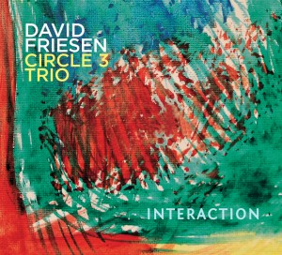CD Review: The trio's joyful interactions offer surprise, beauty, and depth at every turn. "...a fabulous musical fabric with rippling and sometimes broodingly percussive, tumbling grooves upon which foundation he creates a unique sonic architecture." - JazzDaGama
Cadence Critic's Poll
Top Ten CDs of 2019
Top Ten Critic's Pick
David Friesen Interaction, Origin Records
The David Friesen compositions are all gorgeous, rich and accessible, each tune more beautiful than the first and absolutely wonderful soloing and ensemble play at its highest level. JM/Jazz Clubscene

Everything the trio plays is colored with a pronounced individuality. The harmonic depth, intense rhythm and subtle interaction they employ mesmerizes an audience. D. Ramsey/Downbeat, Jazz Times
David Friesen, Prodigious technique … compelling story telling … mood-exploring … spaciousness of spirit … one of those musicians who can never get enough of music. William Minor
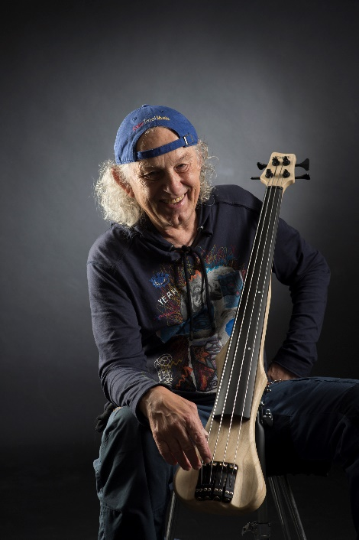David Friesen-hemage bass, piano www.davidfriesen.net
It’s been said of David Friesen that He does for the art of bass playing what Pythagoras did for the triangles Patrick Hinely/Jazz Times
David Friesen has recorded over 80 CD's as a leader/ co-leader and appeared as a sideman or featured artist on more than 100 recordings. He has performed and/ or recorded with many of the great names and legends of jazz including: Stan Getz, Dexter Gordon, Joe Henderson, Sam Rivers, Michael Brecker, Bud Shank, Dizzy Gillespie, Woody Shaw, Freddy Hubbard, Art Farmer, Clark Terry, Joe Venuti, Mal Waldron, Jaki Byard, Kenny Drew Sr., Chick Corea, Milt Jackson, Slim Gaillard, John Scofield, Philly Joe Jones, Elvin Jones, Paul Motian, Jack Dejohnette, Airto Moreira, and many others. He has performed in concert as a soloist (Friesen is one of two or three bassists in the world that is able to play a solo concert and keep an audience riveted) and with his own groups throughout the United States, Canada, United Kingdom, Sweden, Denmark, Norway, Finland, Germany, Belgium, Switzerland, The Netherlands, France, Spain, Portugal, Italy, Austria, Hungary, Slovenia, Turkey, Poland, Japan, Australia, New Zealand, Argentina, Chile, China, Russia, Lithuania, Czech Republic, Nigeria and the Ukraine.
David Friesen is included in 2 recent separate polls as one of the 100 Greatest Jazz Bassists of all time, and one of 20 of the most influential jazz bassists in the history of jazz.
In 1997 he was nominated for the best jazz bassist in the American Jazz Awards ceremony in Los Angeles.
Friesen was inducted into the Oregon Music Hall of Fame at the first induction ceremony Sept. 2007 and the Oregon Jazz Society Hall of Fame May 2012.
Friesen has written two musical scores for animated shorts, both of which have been Academy Award Nominees
David Friesen’s original composition Playground placed 2nd in the 2014 International Songwriting Competition with over 18,000 applicants.
Bassist David Friesen is a phenomenon, a player whose musicianship, tone, time and imagination are uncategorizable. Nat Hentoff

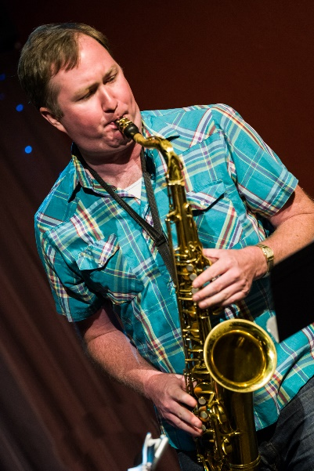Joe Manis-tenor, soprano sax
...intensity and sophistication in equal measure Distrito Jazz.com
SteepleChase recording artist Joe Manis is noted for the strength of his "intense, updated take on the glorious Rollins-'Trane tradition." (Willamette Week) He released his debut album Evidence in 2009.
Manis was the recipient of a 2013 Oregon Arts Commission Individual Artist Fellowship. Manis plays alto saxophone with the Alan Jones Sextet, has toured Europe as a duo and trio with David Friesen, and plays with Friesen's Quartet and Quintet. He also appears on Risky Notion (Four stars & Best Albums of 2015, DownBeat Magazine) on Origin Records with George Colligan's Theoretical Planets. Manis has played with Dr. Thomas Mapfumo and the Blacks Unlimited, including a performance at Carnegie Hall's Zankel Hall, and appears on their album Rise Up! On Real World Records; he has also performed with the George Colligan Quartet, the Chuck Israel’s Jazz Orchestra, the Ken Schaphorst Big Band, the Temptations, comedian Bob Newhart, Wayne Newton, the Oregon Bach Festival Orchestra, the Sunriver Music Festival Orchestra, the Eugene Symphony, and the Eugene Opera.
Manis has presented jazz masterclasses across the country, including at Whitman College, University of Texas at Arlington, University of Oregon, Ferris State University, Willamette University, Portland State University, Southern Oregon University, Portland Community College, Spokane Falls Community College, and Lane Community College. He received a Master of Music in Jazz Studies-Performance with Academic Honor from the New England Conservatory and a Bachelor of Music in Jazz Studies from the University of Oregon. Additional studies were at the Eastman School of Music. He is a current faculty member at Portland State University and Mt. Hood Community College and a former music faculty member at Umpqua Community College. His article "Rhythmic Analysis: Jeff 'Tain' Watts - 'Housed From Edward'" was published in the March 2012 edition of JAZZed Magazine. Manis also writes for the Jazz Society of Oregon's Jazzscene. He is a featured artist on the David Friesen CD, Structures.
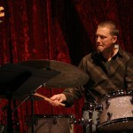Charlie Doggett-drums
Doggett, a drummer of imagination and curiosity, propels each tune with cunningness and unrelenting swing. John Barron/All About Jazz.com
Charlie Doggett, drummer/percussionist/composer, is one of the most enigmatic drummers on the world jazz music scene today.
He has earned a BA in Music from the University of Oregon, where he studied with Charles Dowd and Gary Versace. He has performed with a long list of stellar artists including, Charles McPherson, John Gross, Javon Jackson, Ralph Bowen, David Friesen, Glen Moore, Ben Wolfe, Nancy King, David Frishberg, Darrell Grant, Poncho Sanchez, and Titos Sompa. He has appeared at such festivals as, British Columbia’s du Maurier International Jazz Festival, the Medicine Hat Jazz Festival, Alberta, Canada, Seattle's Bumbershoot Festival, the Ballard Jazz Festival, and the Mt. Hood Festival of Jazz. His performances have been featured on Branford Marsalis’ NPR Jazz Set Program, the WB's prime time show "Jack & Jill" and the title track for the movie "Kat and Allison" He is on the David Friesen CD releases Five and Three, Brilliant Heart, Morning Star, Where the Light Falls and Triple Exposure.
PRESS RELEASE
Legendary American jazz bassist will be leading a trio with 2 new stars on the jazz scene in the USA, Joe Manis-tenor, soprano sax and the amazing Charlie Doggett-drums. "The sum of the whole is far greater than the figuration of its parts. Friesen and his trio have forever tread outside the ordained paths and will never cease to do so. Be ye dumbstruck with awe at the pure artistry of it all." FAME MUSIC MAGAZINE

